``

**كلية العلوم الحاسوبية والمعلوماتية**

Faculty of CSI

**LifeAssist**

*Students:*

|  |  |
| --- | --- |
| Dalaa Yaser Saqer | 202210366 |
| Toleen Malek Al-shattel | 202210551 |
| Sara Nabeel Abuodeh | 202210418 |

*Supervisor:*

Dr. Alaa abuthouabeh

*Amman - Jordan*

*2024/2025*

**Table of Contents**

1.1 Problem Statement and project Scope page 1

1.2 Project Plan and Schedule

2. System Analysis page 2

2.1 Functional Requirements

2.2 Use Case Diagram

3. System Design page 3

3.1 Class Diagram

3.2 ER-Diagram (if a database will be used)

3.3 User Interface

* 1. Problem Statement and project Scope

The system has been facing problems due to its paper-based appointment

system. With the increase in the number of patients visiting, it has

become diﬃcult to manage the appointment system manually. Recording

of appointments and creating registers by pen and paper has become a

Access to reliable medical equipment is a significant challenge for individuals, caregivers, and healthcare providers.

Many patients recovering at home or managing chronic conditions require essential health products like oxygen concentrators, hospital beds, or wheelchairs, The project involves developing an online platform dedicated to the sale and rental of medical equipment to address the identified challenges.

This scope defines the foundation for a comprehensive solution to make medical equipment accessible, affordable, and convenient.

1.2 Project Plan and Schedule

Gantt Chart:

Figure 1: This figure illustrates the project plan, including the start and end dates of each

Figure 1: Gantt Chart of project

2. System Analysis

* 1. Functional Requirements

1.User Management

1.1. The system must allow users to register for an account with basic details (name, email, phone number, address).

2. Product Catalog

2.1. The website must display a categorized list of medical equipment available for sale and rent.

2.2. Each product must have a detailed description, specifications, pricing (purchase and rental), and high-resolution images.

3. Customer Support

3.1. A live chat feature must be available for users to ask questions or request assistance.

3.2. FAQs and product guides must be accessible to address common queries.

4. Reviews and Ratings

4.1. Users must be able to leave reviews and ratings for purchased or rented products.

4.2. The system must display average ratings and reviews on product pages to guide future customers.

5. Rental Management

5.1 The system must allow users to choose rental periods (daily, weekly, or monthly) and display corresponding prices.

5.2. A notification system must remind users of upcoming rental expirations and provide options to extend the rental period.

6. Shopping Cart and Checkout

6.1. Users must be able to add products to a shopping cart with options for both purchase and rental.

6.2. the system must support editing the cart (e.g., changing quantities, removing items, or adjusting rental durations).

* 1. Use Case Diagram

Figure 2: This figure presents the use case diagram, illustrating the interactions between the actors and the system.

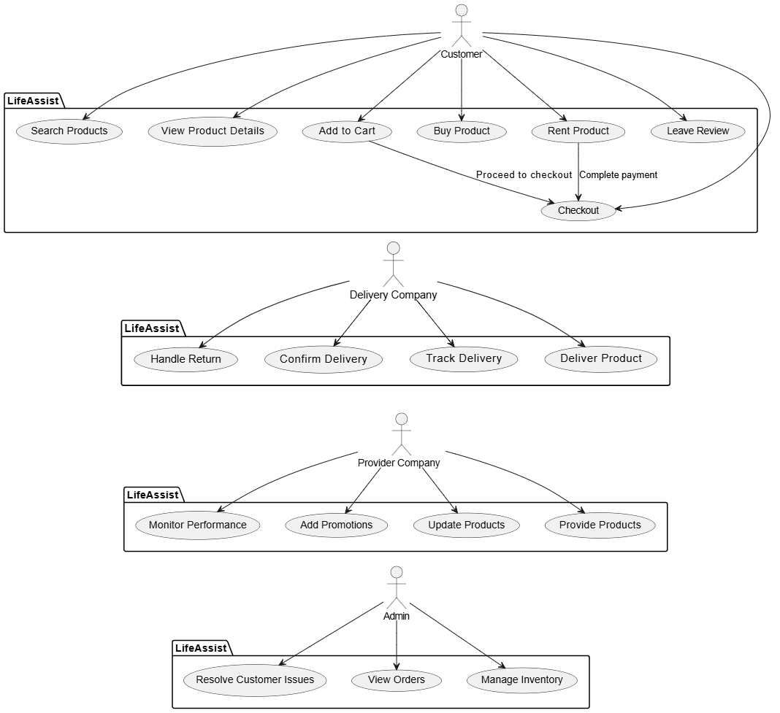

Figure 2: Use Case diagram of system

3. System Design

3.1 Class Diagram

Figure 3: This figure depicts the class diagram, detailing the structure of the system, including its classes, attributes, methods, and relationships.

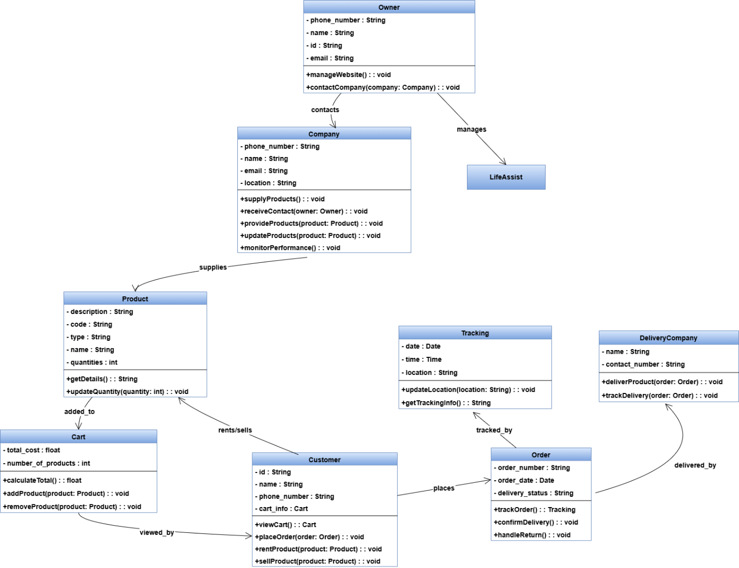

Figure 3: Class diagram of Appointment system

3.2 ER-Diagram

Figure 4: This figure illustrates the Entity-Relationship (ER) diagram, showcasing the entities, attributes, and relationships within the system.

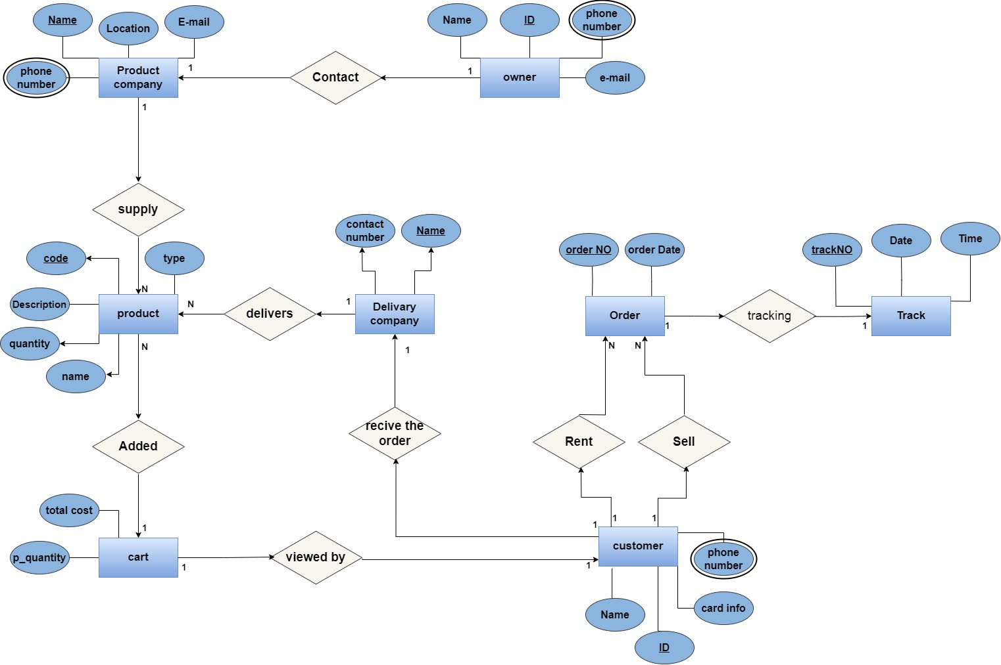

Figure 4: ER diagram of Appointment system

3.3 User Interface

Figure 5: This figure showcases the user interface design, highlighting the main components and layout of the system's front end.

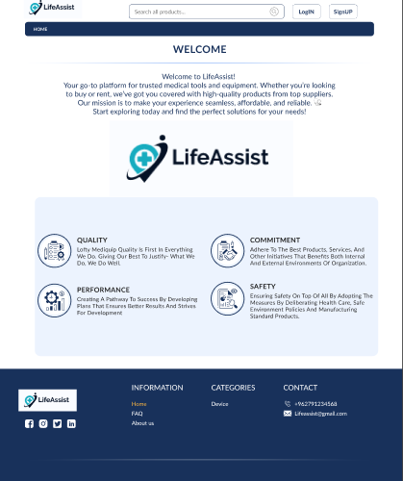

Figure 5: Main UI of Appointment system

Figure 6: This figure presents all the user interface designs of the system, illustrating the visual elements, navigation flow, and user interactions.

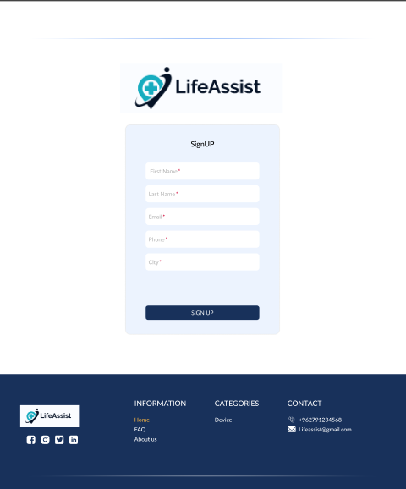

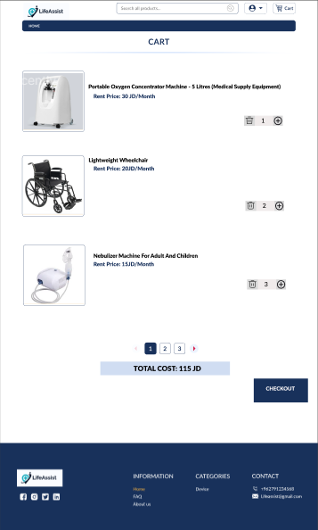

Figure 6: Show All UI of system